**M.I.T. LAB Assignment – 06**

**U19CS012**

(1) The following block of data is stored in memory locations from 3055H to 305AH. WAP to transfer the block of data in reverse order at same memory location.

DATA (HEX): 22, A5, B2, 99, 7F, 37

Notepad Code:

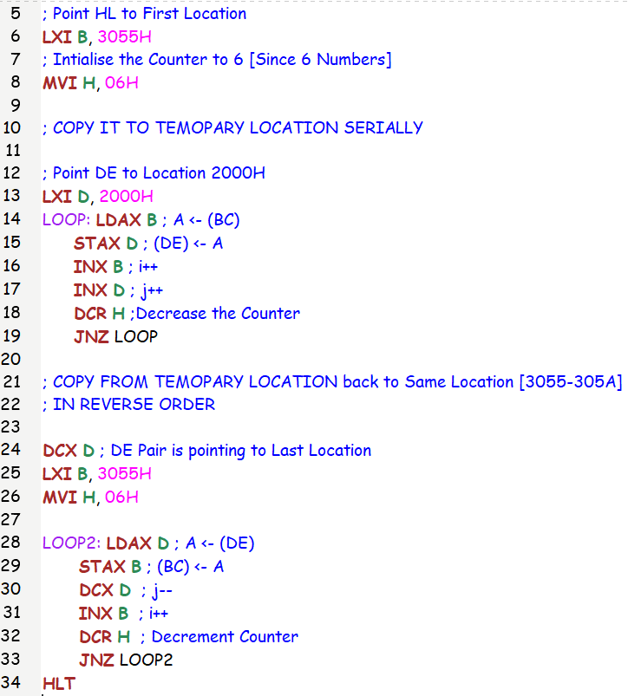

Test Case:

Input Data: 34, 165, 178, 153, 127, 55 [Decimal]

Output Data: 55, 127, 153, 178, 165, 36 [Decimal]

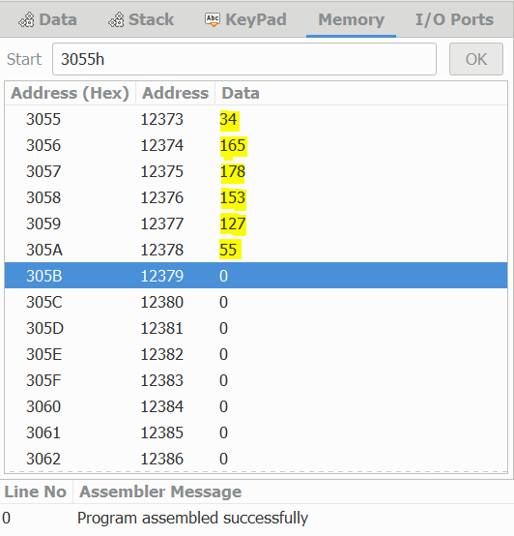 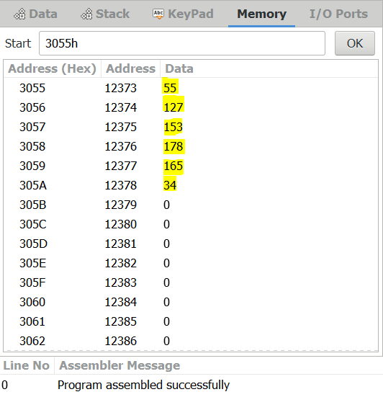

(2) Find the square of the given numbers from memory location 6100H and store the result from memory location 7000H.

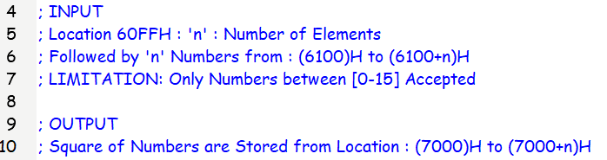

Notepad Code:

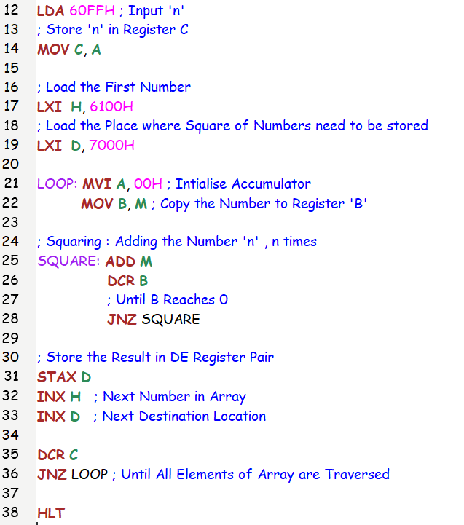

Test Case:

Input Data: 13, 9, 4, 7, 12, 1, 8, 14, 10, 15 [Decimal]

Output Data: 169, 81, 16, 49, 144, 1, 64, 196, 100,225 [Decimal]

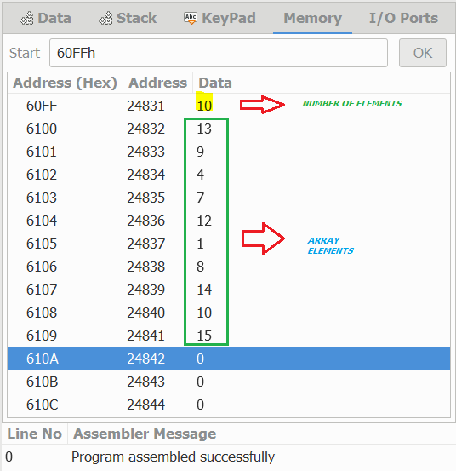 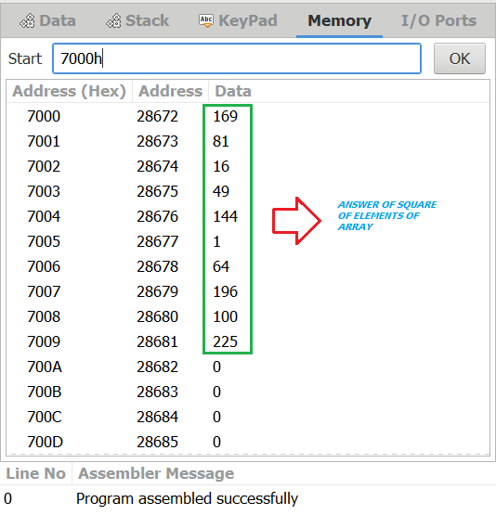

(3) WAP to find Factorial of a given number using Call and Subroutine.

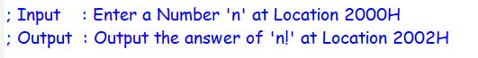

Notepad Code:

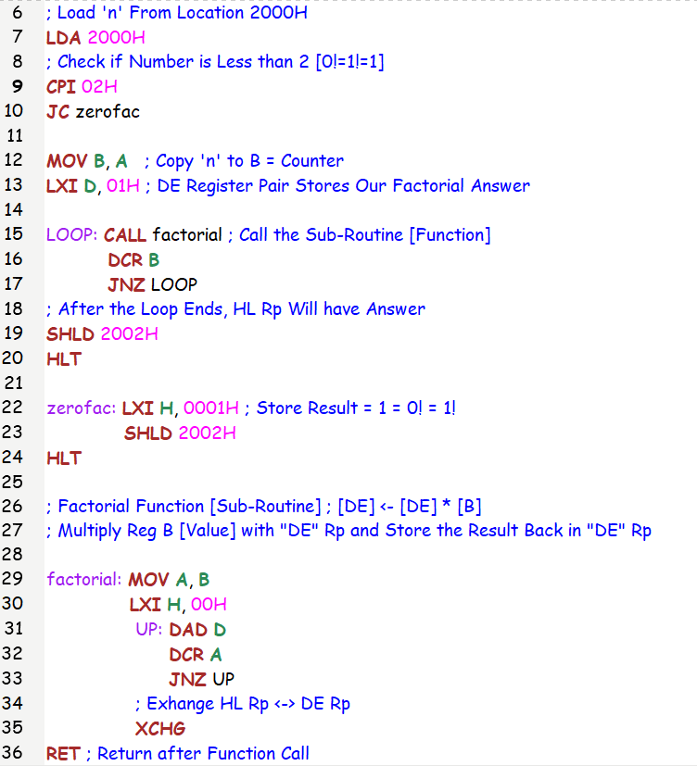

Test Case:

|  |  |  |
| --- | --- | --- |
| Number (n) | Factorial (n!) [Decimal] | Factorial (n!) [Hexa-Decimal] |
| 0 | [0 1] | (00 01)H |
| 1 | [0 1] | (00 01)H |
| 2 | [0 2] | (00 02)H |
| 3 | [0 6] | (00 06)H |
| 4 | [0 24] | (00 18)H |
| 5 | [0 120] | (00 78)H |
| 6 | [2 208] | (02 D0)H |
| 7 | [19 176] | (13 B0)H |
| 8 | [157 128] | (9D 80)H |

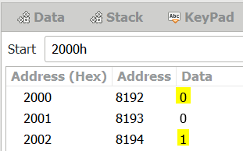 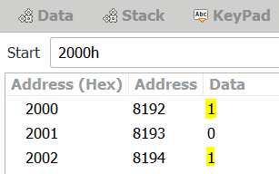 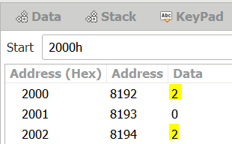

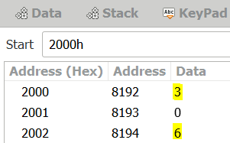 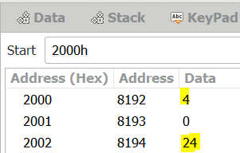 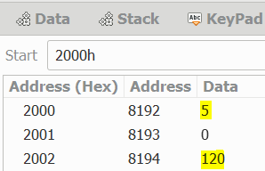

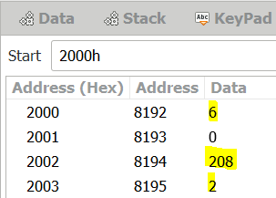 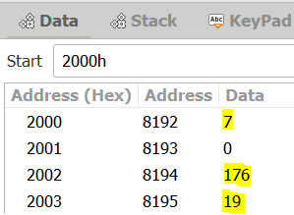 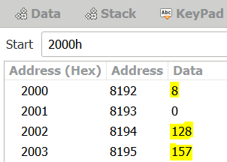

(4) WAP for Fibonacci Series using Call and Subroutine.

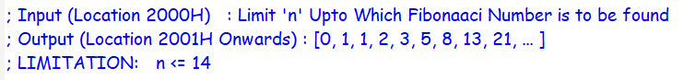

Notepad Code:

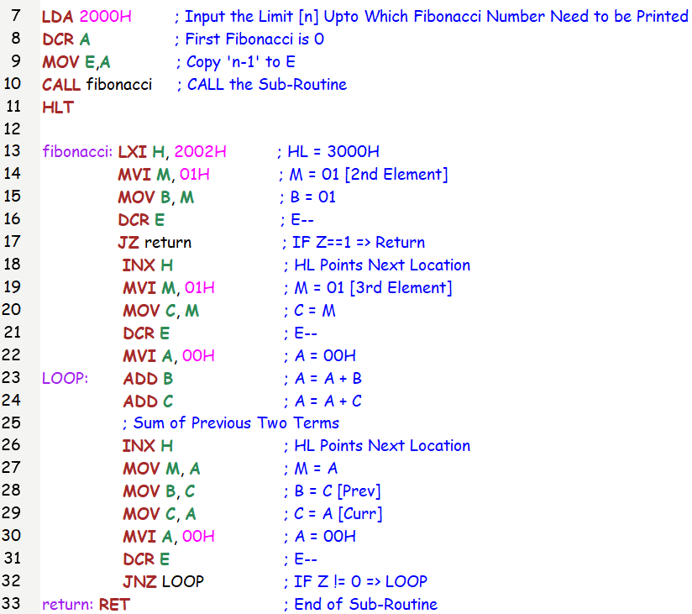

Test Case:

First 10 & 14 Numbers of Fibonacci Series

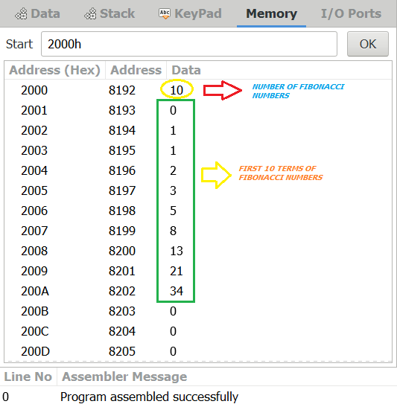 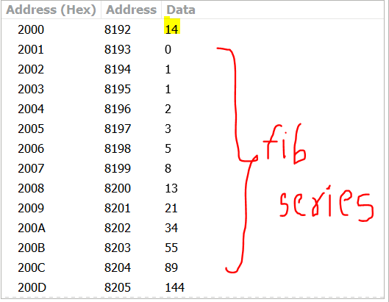

(5) WAP to find Multiplication of Two 8-Bit Numbers using Call and Subroutine.



Notepad Code:

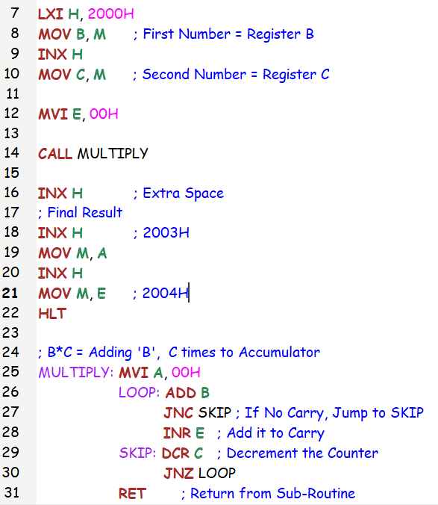

Test Case:

(1) 12 * 6 = 72 (2) 17*19 = 323 = (01 43)H = (01 67)

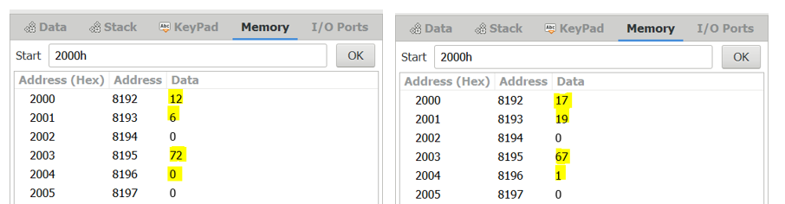

SUBMITTED BY:

BHAGYA VINOD RANA

[***U19CS012***]